Data Structures for a Production Line Quality Inspection System: Proof of Concept

Sandip Sitaula
University of Cumberland
MSCS-532-B01: Algorithms and Data Structures
July 21, 2026

Data Structures for a Production Line Quality Inspection System: Proof of Concept
Partial Implementation Overview
This deliverable extends the Phase 1 design into a working proof of concept for the production-line quality inspection system described in the Deliverable 1 report. All four data structures from that design were implemented: InspectionRegistry (hash table), StationQueue (FIFO queue), TriageQueue (priority queue), and SKUTrie (trie). Each class exposes only the operations that the pipeline actually needs, insertion, lookup, removal, and traversal, rather than exposing the underlying Python container directly, so the internal representation of each structure can change in a later phase without breaking any code that depends on it.
InspectionRegistry. InspectionRegistry wraps a dict keyed by serial number and exposes start_unit, update_stage, get_record, and close_unit. This is the piece the rest of the pipeline depends on most heavily: every other stage reads from or writes to a unit's record by serial number, so its correctness and constant time behavior directly determine how the whole system performs.
StationQueue. StationQueue wraps a collections.deque and exposes enqueue, dequeue, and peek. In this PoC it models the single intake line units enter on before triage; the full design calls for one StationQueue per physical station, and the class was written generically enough that instantiating several independent queues, one per station, requires no changes to the class itself.
TriageQueue. TriageQueue wraps heapq and exposes push and pop_highest_priority. It orders units by an integer priority representing shipment urgency, using a negated value and a tie-breaking counter so heapq's min-heap behaves as a max-priority queue and equal priorities are still resolved in arrival order. A unit's cosmetic condition grade (A, B, or C) is recorded separately on its record through InspectionRegistry.set_grade and does not affect this order.
SKUTrie. SKUTrie exposes insert, has_prefix, and contains. In this PoC it stores the small set of SKUs that are part of the current shipment plan, and the demonstration uses it both to validate a unit's SKU and to detect when a scanned code is a plausible OCR misread, a prefix of a needed SKU but not an exact match.
What is intentionally left out of this PoC is everything around these four structures: there is no real camera or OCR input, no database-backed persistence for the registry, and no networked communication between stations. The Next Steps section outlines what would need to be added to close that gap.
Demonstration and Testing
Two forms of testing are included. First, inspection_system.py has a self-test block that exercises each class in isolation and checks specific edge cases: an empty TriageQueue and an empty StationQueue both return None rather than raising an error, two units pushed to the TriageQueue with the same priority come out in the order they were pushed, and a string that is a prefix of a stored SKU but not itself a complete SKU is correctly reported as not contained in the trie. All of these assertions currently pass.
Second, a separate script, demo.py, wires the four structures together into a short simulated run of the full pipeline, rather than testing each one in isolation. Four units are pushed through data wipe, triage, a functional test, and a packout routing decision. Each unit is also assigned a cosmetic condition grade of A, B, or C at intake, recorded for reference only. The scenario was built to exercise several cases at once: a unit with no onboard memory that skips the wipe, a unit that fails its functional test, a unit whose SKU is not part of the current shipment plan, and a unit whose scanned code is a prefix of a needed SKU rather than an exact match. The relevant portion of the output is shown below.
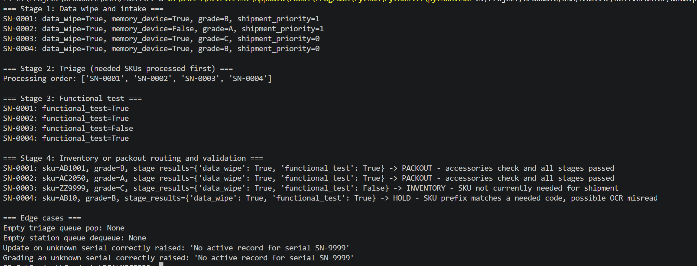This confirms the four structures correctly hand off to one another: the registry retained each unit's full stage history through triage and the functional test, the trie distinguished a needed SKU, an unneeded SKU, and a plausible OCR misread from one another, and the triage queue reordered units by shipment priority rather than processing them in the order they arrived, while each unit's cosmetic grade was recorded but had no effect on that order. The demo script also exercises the same edge cases as the unit tests, an empty queue, an empty heap, and a lookup for a serial number that was never registered, and confirms the registry raises a KeyError rather than failing silently in the last case.
Implementation Challenges and Solutions
A few issues came up moving from the Phase 1 design to working code. The first was tie-breaking in the priority queue: Python's heapq compares tuples element by element, so once the negated grade is equal for two units, heapq would try to compare serial numbers as the next tiebreaker, which is not the behavior this system wants. This was resolved by inserting a monotonically increasing counter as the second element of each tuple, so ties are always broken by insertion order and the serial number is never compared directly.
The second was deciding how much of the underlying container to expose. An early version of InspectionRegistry allowed callers to access the internal dict directly, which meant nothing prevented a bug elsewhere in the pipeline from deleting or overwriting a record incorrectly. Wrapping the dict behind start_unit, update_stage, get_record, and close_unit closed that gap and made it possible to test the registry's behavior independently of how any other stage uses it.
The third was ordering the routing decision at packout correctly. The first version of demo.py checked whether a unit's SKU was needed before checking whether it had passed every prior stage, which meant a unit that failed its functional test but happened to have a needed SKU would still look like it might be eligible for packout until the very last check. The demo script currently checks SKU status before stage results; a production version would check stage results first so a failed unit is never considered for packout regardless of its SKU, and this ordering is called out explicitly as a known simplification in this PoC rather than left as an implicit assumption.
A fourth issue was a design change to the TriageQueue itself. The initial version of demo.py used the intake condition grade (A, B, or C) as the value pushed into the priority queue, on the assumption that a more heavily worn unit should be reviewed before a unit in better condition. On review, this was the wrong criterion: cosmetic condition and shipment urgency are two independent things, and conflating them meant a well-conditioned unit that happened to be urgently needed for an active shipment could be triaged after a unit that was in worse condition but not needed at all. The fix was to add a dedicated set_grade method to InspectionRegistry so a unit's grade is recorded on its record for reference, and to change what gets pushed into TriageQueue to an explicit shipment priority value, 1 if the unit's SKU is currently needed and 0 otherwise, computed by checking the unit's SKU against SKUTrie. The push parameter was also renamed from grade to priority so the class's own signature no longer implied a relationship between the two that the design does not actually have.
Next Steps
Several pieces remain before this becomes a complete application. The registry needs to persist to a database so records survive a restart, rather than living only in memory for the current shift, which was already flagged as a limitation in the Phase 1 report. The four structures need to be wrapped in a single orchestrating class or set of functions that models a unit moving automatically from one station to the next, rather than a script that calls each stage manually in sequence as demo.py does now. The trie needs to support the shipment plan actually changing over time, adding and removing SKUs as new shipment plans are issued, and pairing prefix matches with a fuzzy matching step so a likely OCR misread can be corrected rather than only flagged. Finally, since a real line would have multiple camera or scanner threads updating the registry and station queues at the same time, the next phase should add locking or otherwise make these structures thread safe before they are tested under concurrent access.
Code Snippets
Available in Github Repo: https://github.com/sitaulasandip/MSCS532/tree/main/Deliverable2

References
Ettalibi, A., Elouadi, A., & Mansour, A. (2024). AI and computer vision-based real-time quality control: A review of industrial applications. Procedia Computer Science, 231, 212–220. https://doi.org/10.1016/j.procs.2023.12.195
Maślanka, M., Jancarczyk, D., & Rysinski, J. (2025). Integration of machine vision and PLC-based control for scalable quality inspection in Industry 4.0. Sensors, 25(20), 6383. https://doi.org/10.3390/s25206383
Tapia-Fernández, S., García-García, D., & García-Hernandez, P. (2022). Key concepts, weakness and benchmark on hash table data structures. Algorithms, 15(3), 100. https://doi.org/10.3390/a15030100

